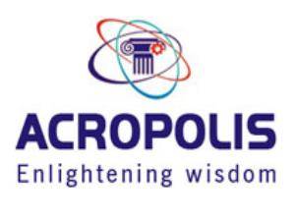 **Acropolis Institute of technology and research**

**201,shanti Avenue phase-,limbodi, INDORE (M.P.) 452020**

**+91 9644295555 aditikumrawat24@gmail.com**

**Career Objective:** Self motivated to be a software developer in an IT industry to utilize my ideas, knowledge and determination for the proliferation of the organization.

# Academic Record:

## Professional Qualifications:

* Pursuing Bachelor of Engineering from Acropolis Institute of technology and research College of Engineering & Technology, Indore affiliated to RGTU with specialization in Information Technology (2021-2024) (Current Average-9.14%)

## Educational Qualifications:

* Senior Secondary School Certificate (10+2) from Board of Secondary Education Bhopal M.P. with 81.2% in the year 2020
* High School Certificate (10th) from Board of Secondary Education Bhopal M.P. with 68.7% in the year 2018

**IT Skills/Core Skills:** C/Python, Fronted

**Extracurricular Activities:** Actively participated in social, cultural and sports activities during my academics

# Achievements:

* Winner in state and district Anuvart Nayas sangeet competition held in the year 2019

➢ Winner in two district Volleyball held in Alirajpur district in the year 2016-17

**Strengths:** Adaptable, Focused **Area of Improvement:** English

**Hobbies:** Listening to Music, Singing

# Personal Details:

Date of Birth : 19th October 2002

Gender : Female

Nationality : Indian

Marital Status : Unmarried

Languages known : Hindi, English

Mother Tongue : Hindi

Father’s Name : Mr.Prakash

Passport Details : Applied for

**Declaration:** I hereby declare that the information furnished above is true to the best of my knowledge. Date: August 10, 2021 **Aditi Kumrawat**

Place**:** Indore